McMaster University

Dept. of Electrical and Computer Engineering

COMP ENG 4TL4 - Term I (Fall) 2023

# **Lab 5 - IIR Filter Design and Analysis**

**Demo Date: Nov. 27**

**Due Date: Dec. 6**

**Tianze zhang 400208135**

**Xiang li 400197429**

# [**zhant22@mcmaster.ca**](mailto:zhant22@mcmaster.ca)

# [**lix289@mcmaster.ca**](mailto:lix289@mcmaster.ca)

**1. Chebyshev Type II lowpass IIR filter**(a)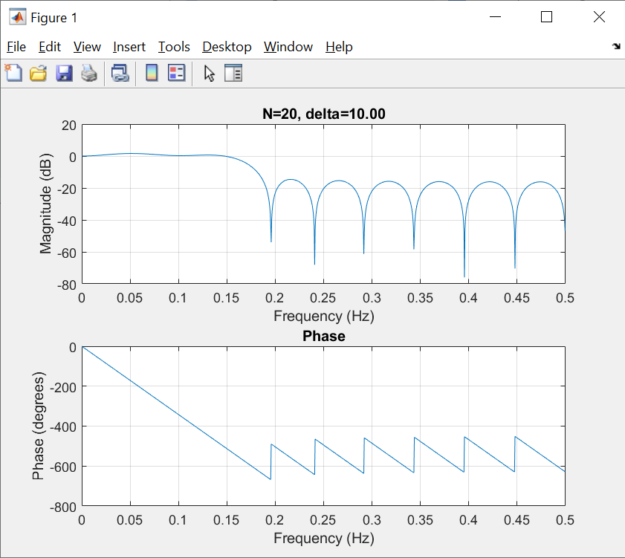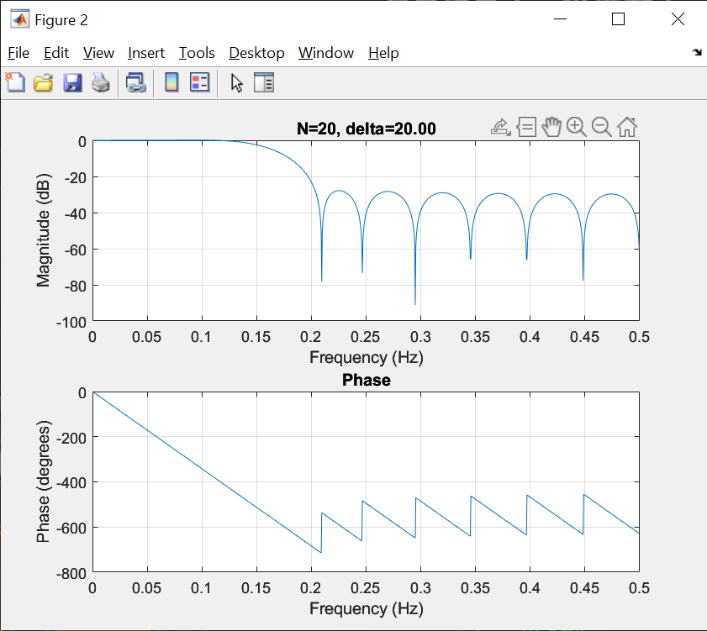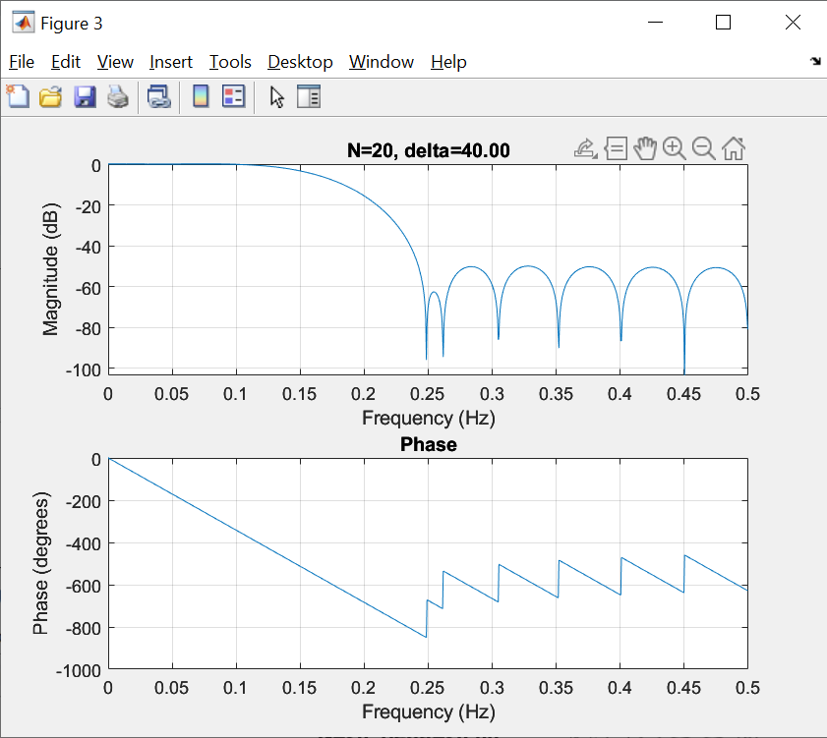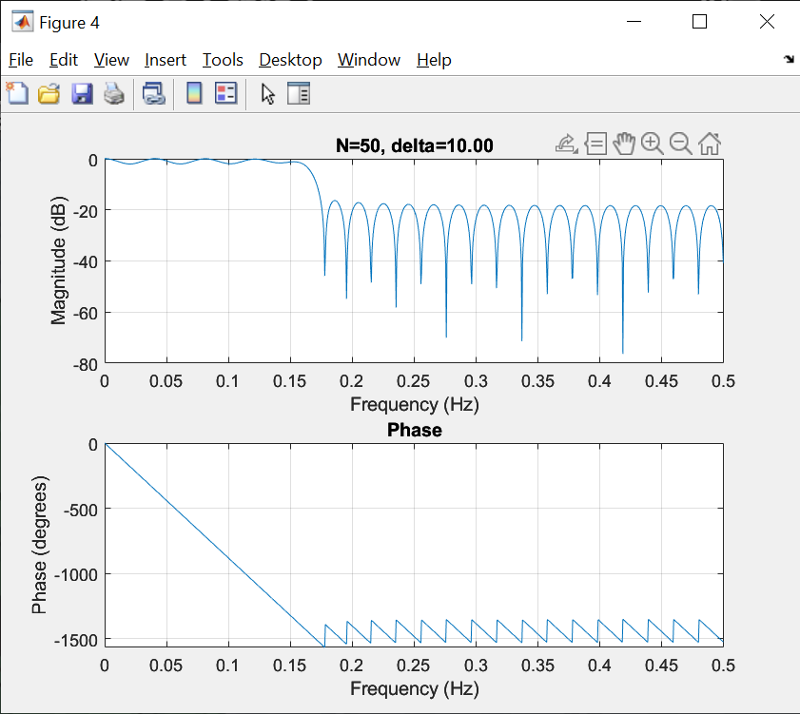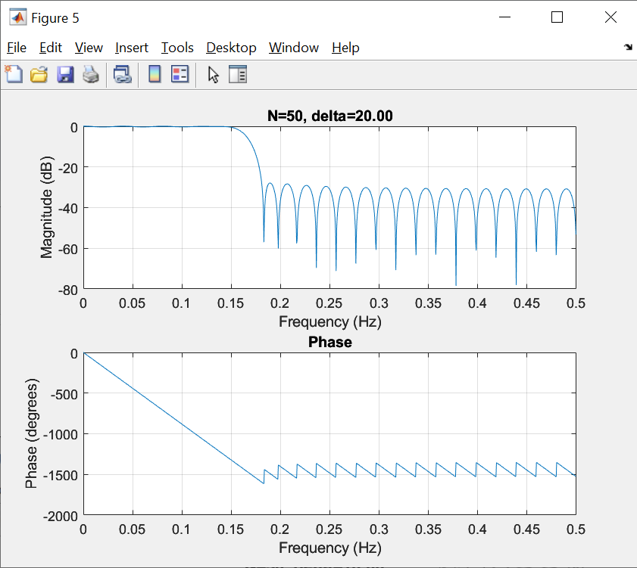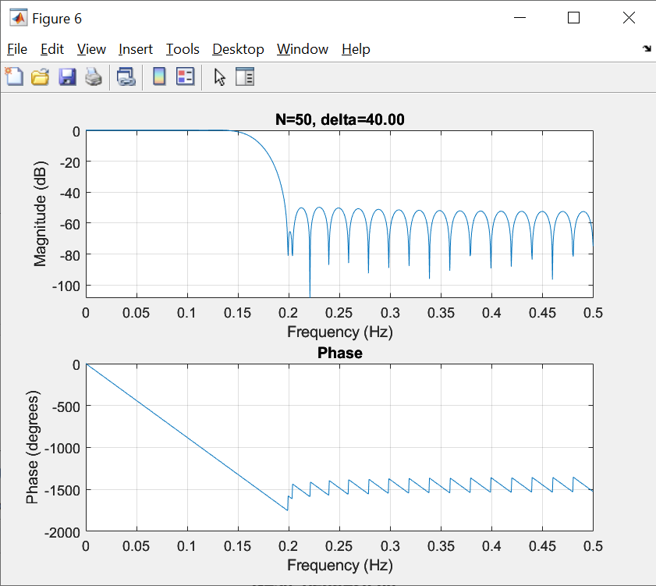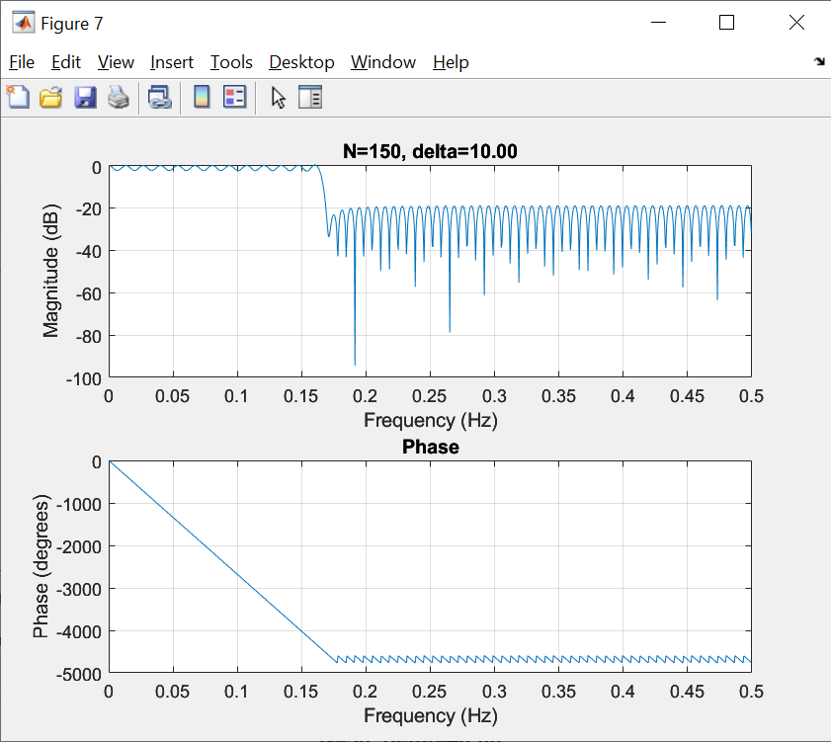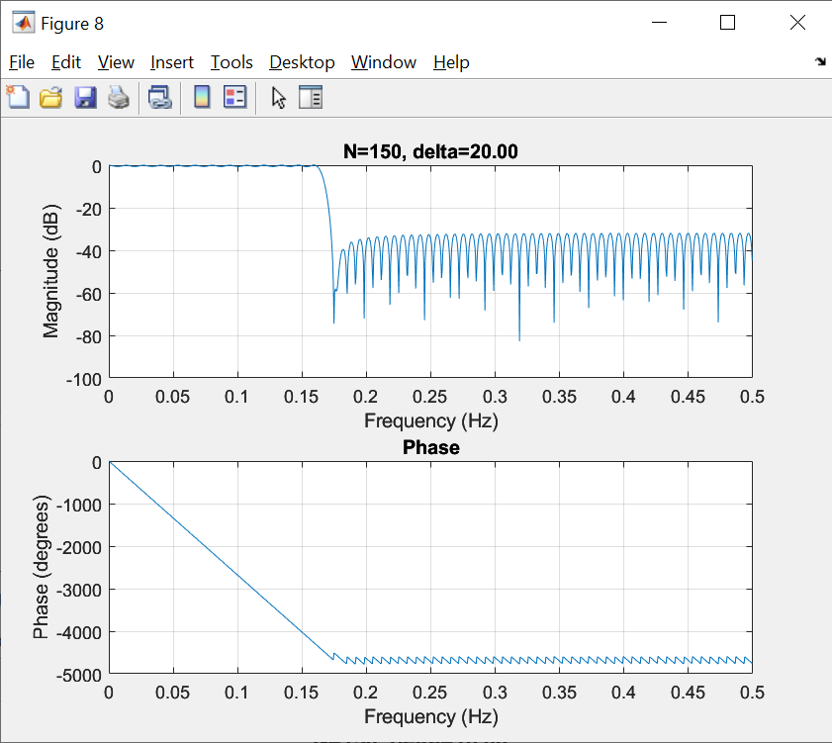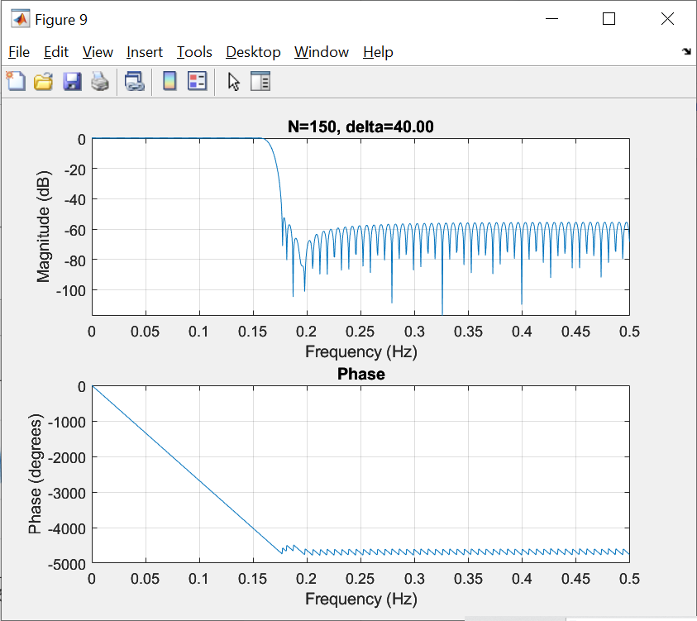

Larger n(filter ordersM) will make passband ripple reduced, stopband attenuation increased and stopband attenuation steeper.

Larger delta(relative sidelobe attenuation) will make passband ripple reduced, stopband attenuation increased and stopband attenuation steeper.

(b)

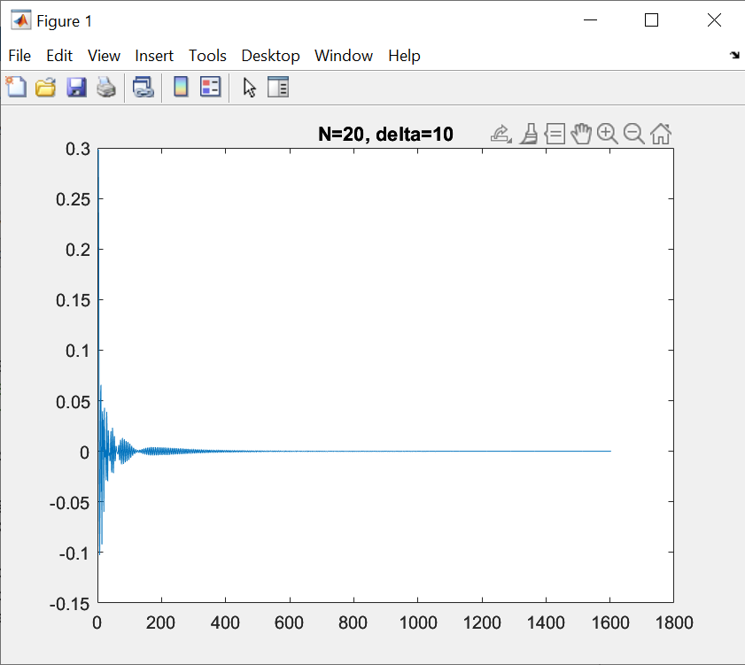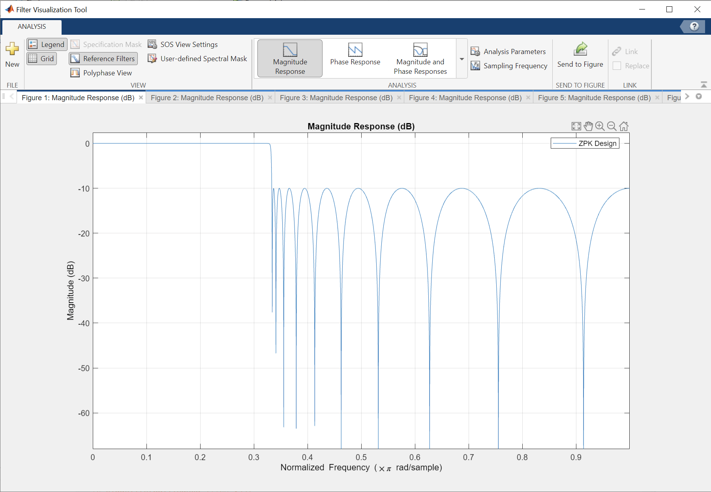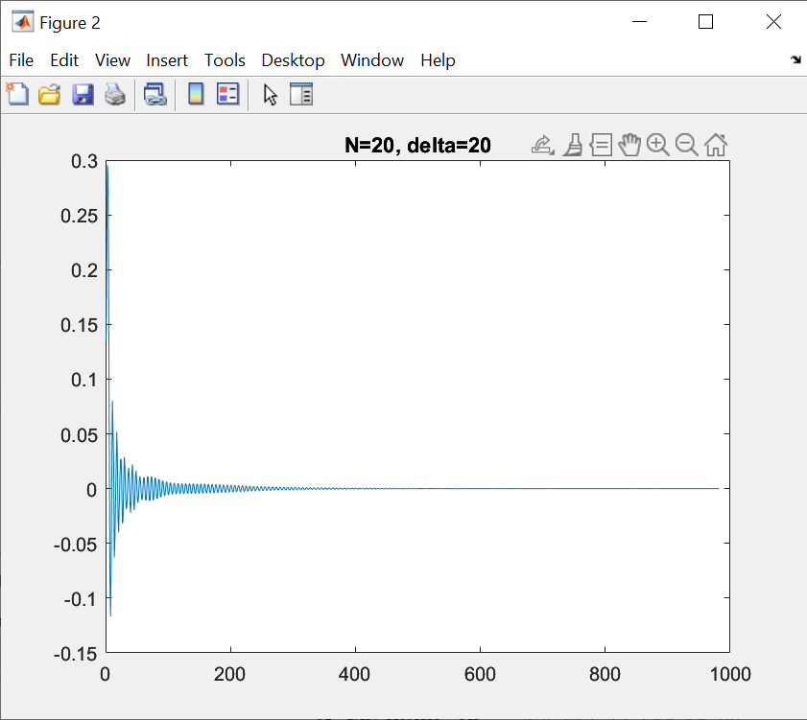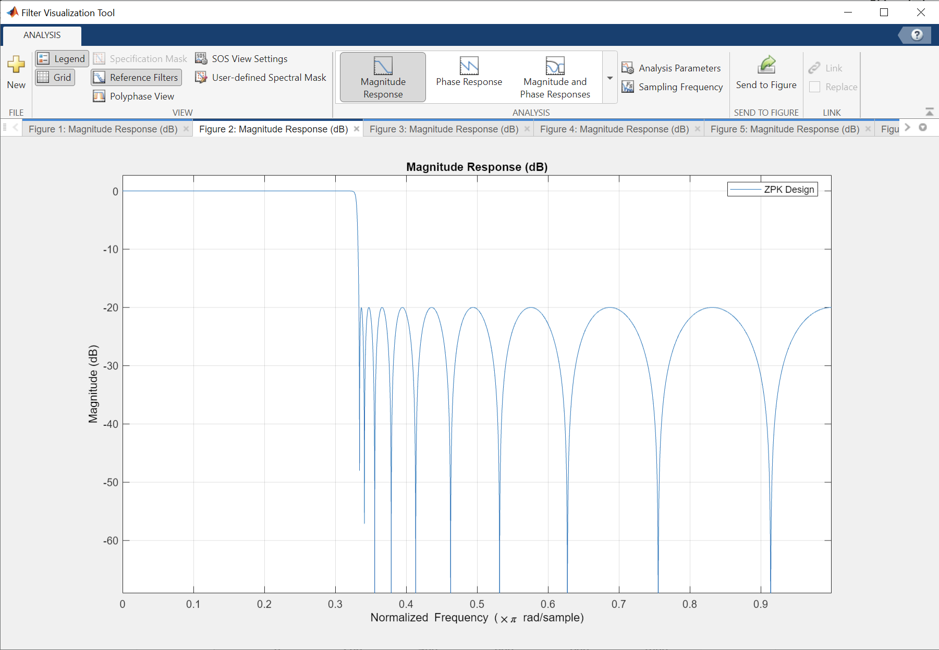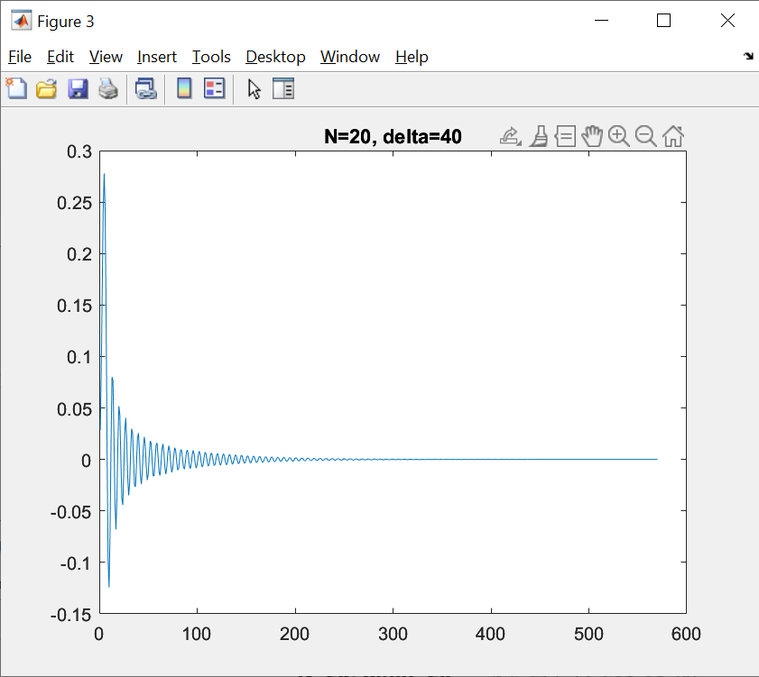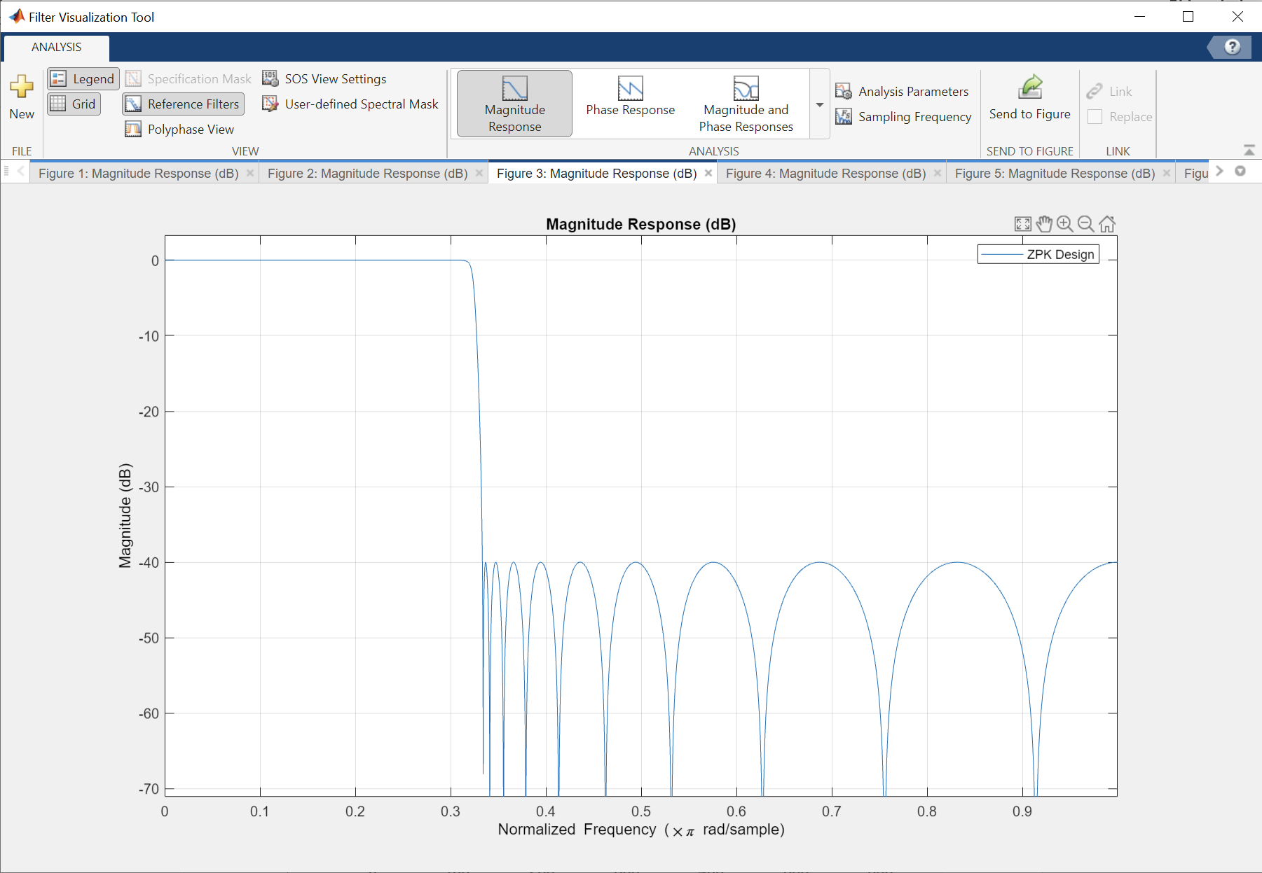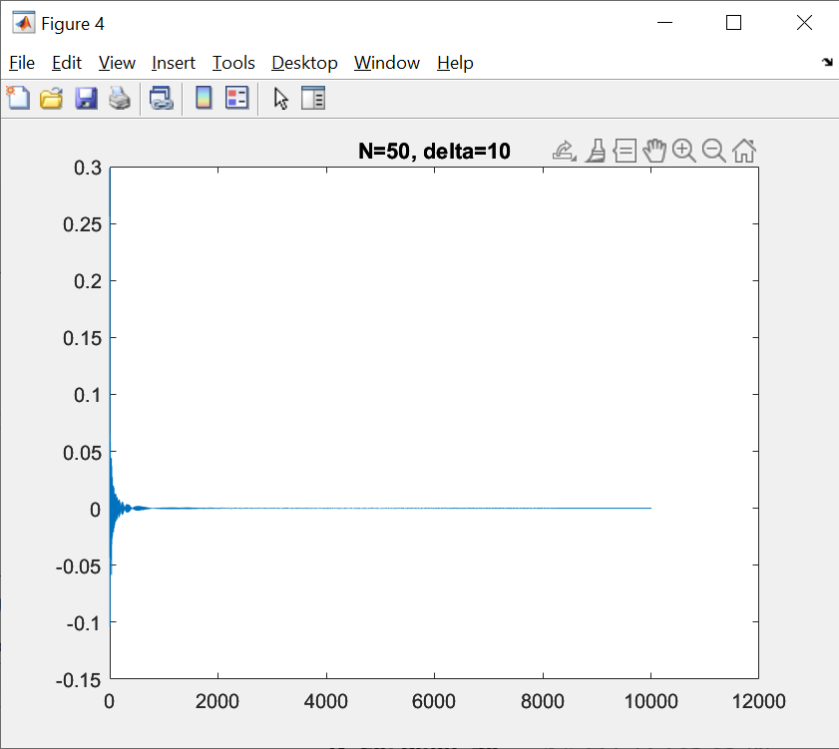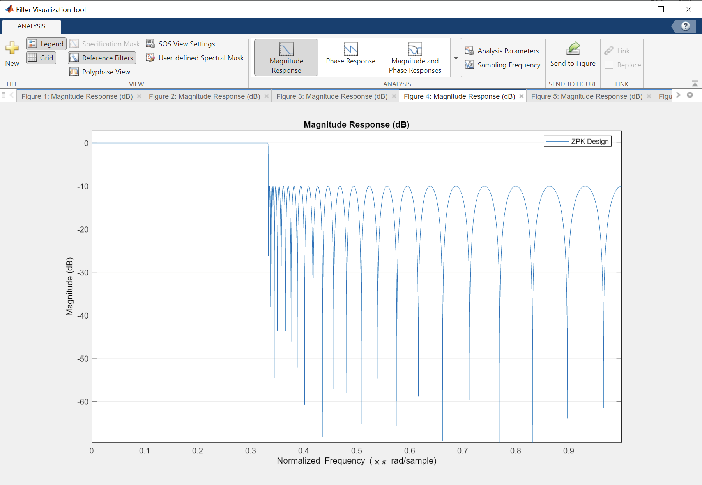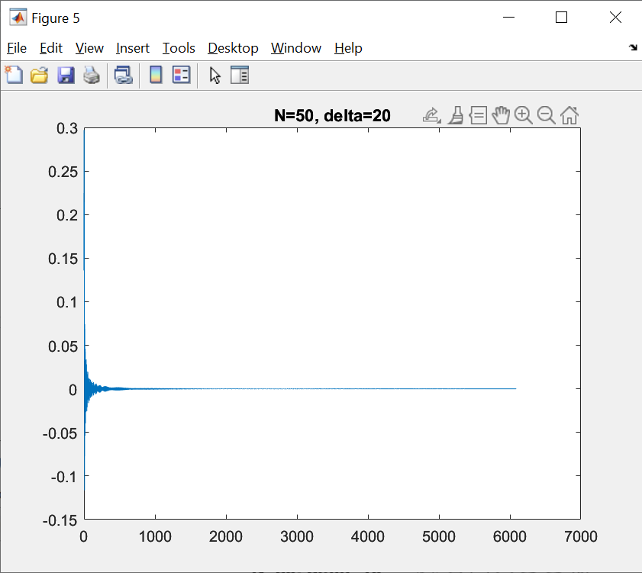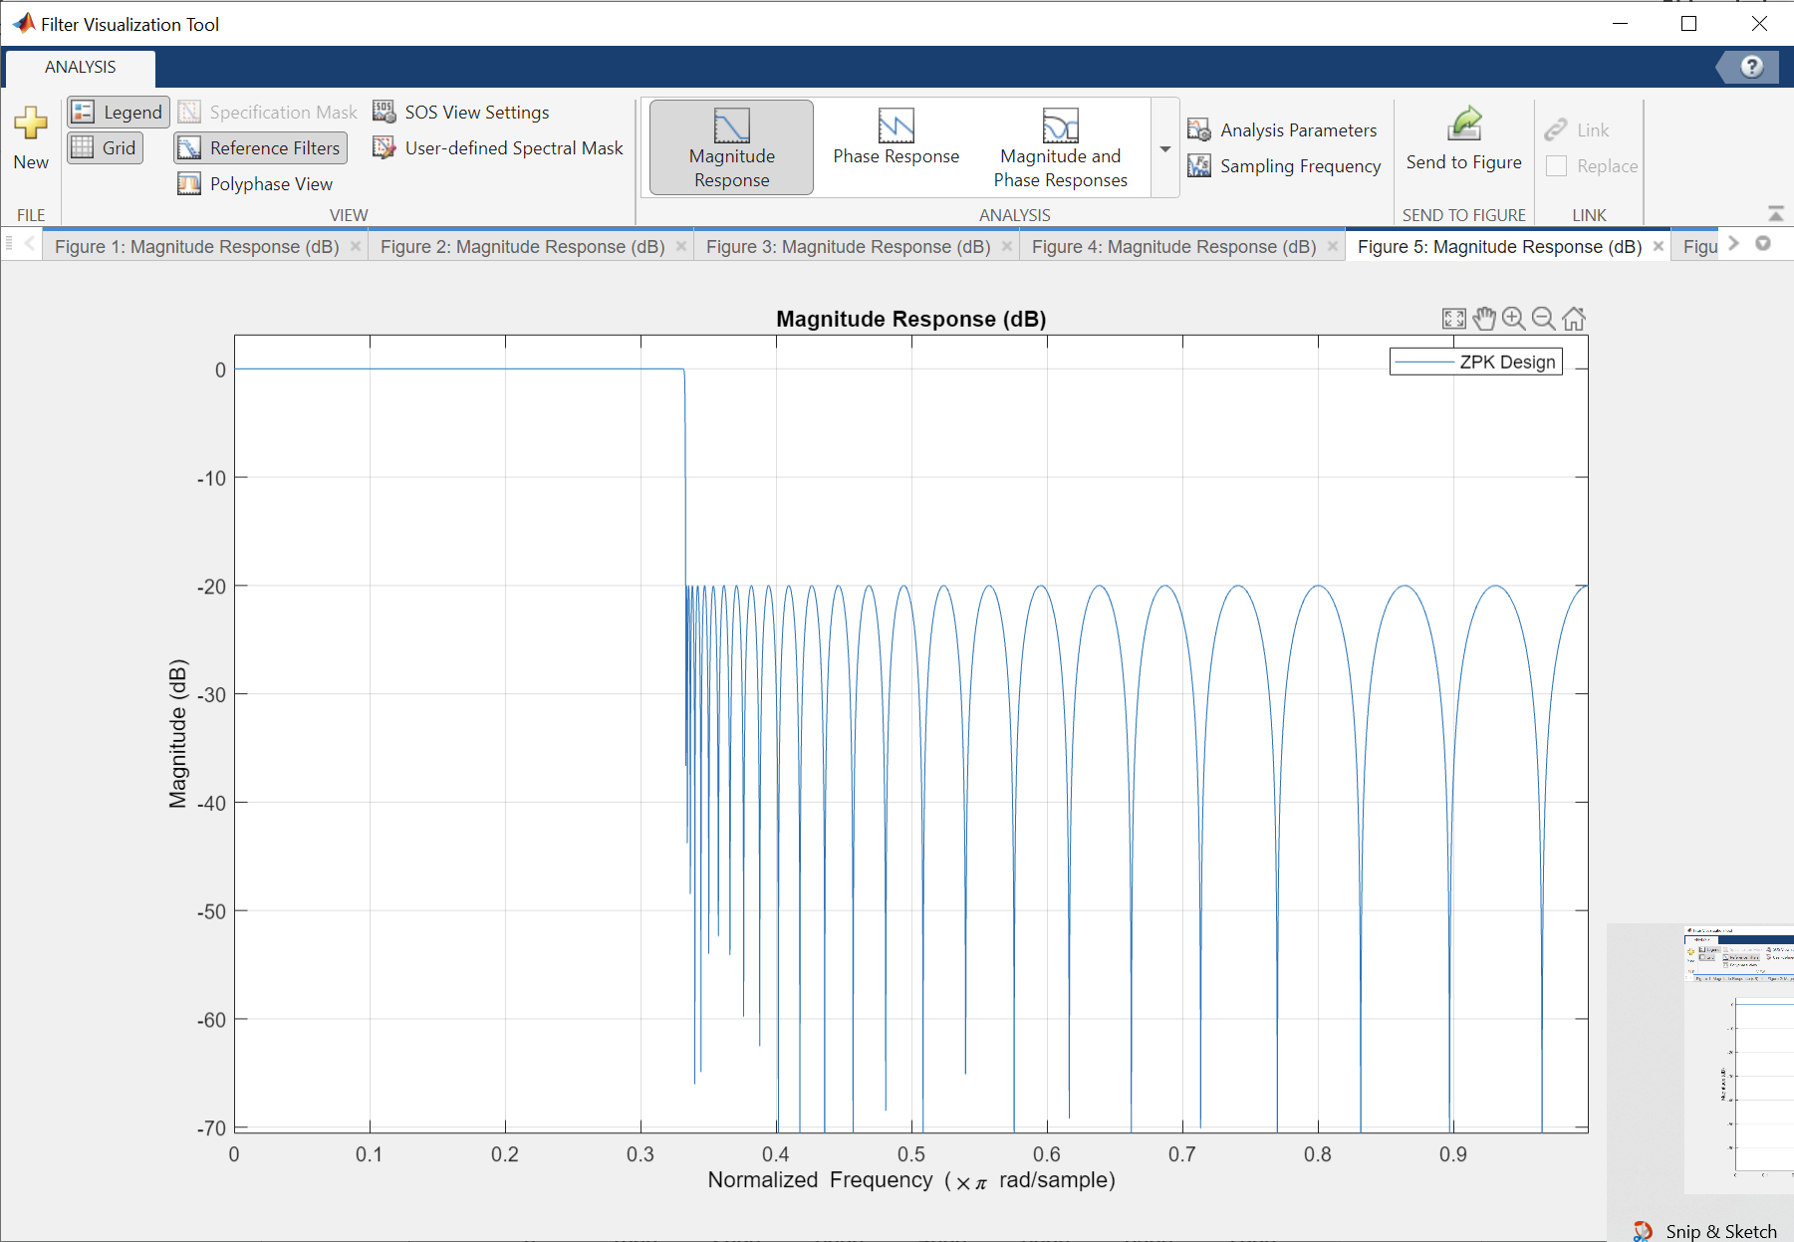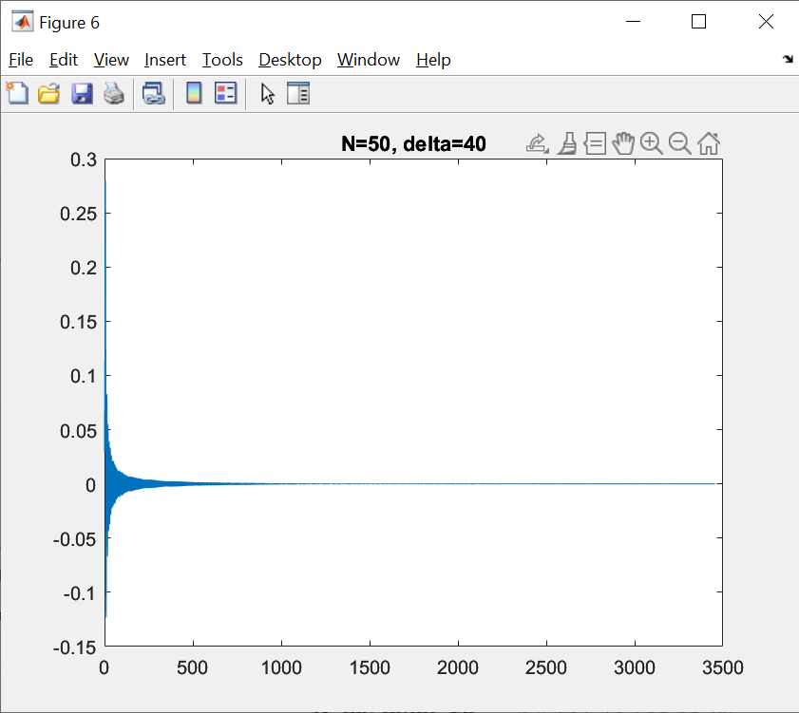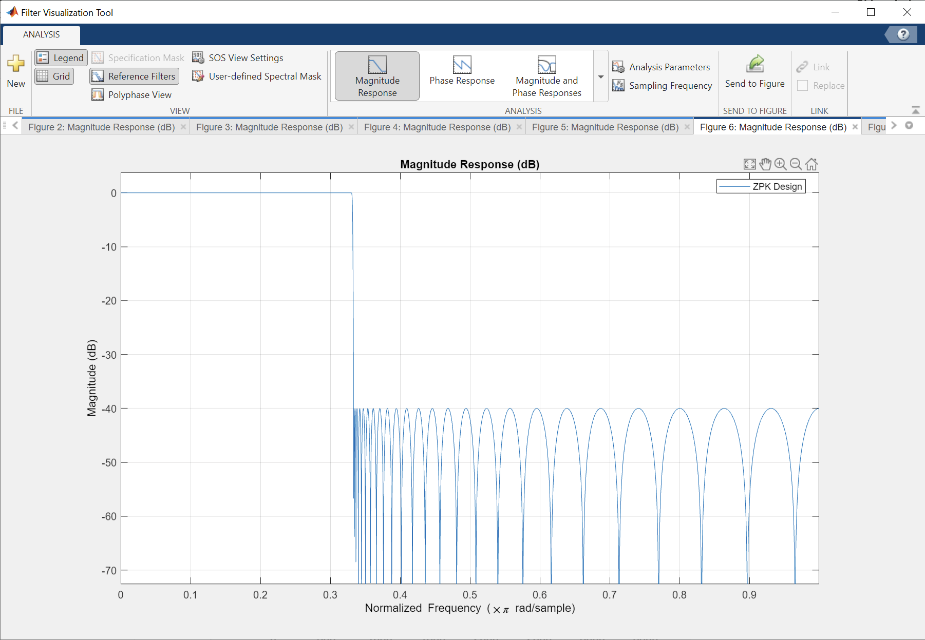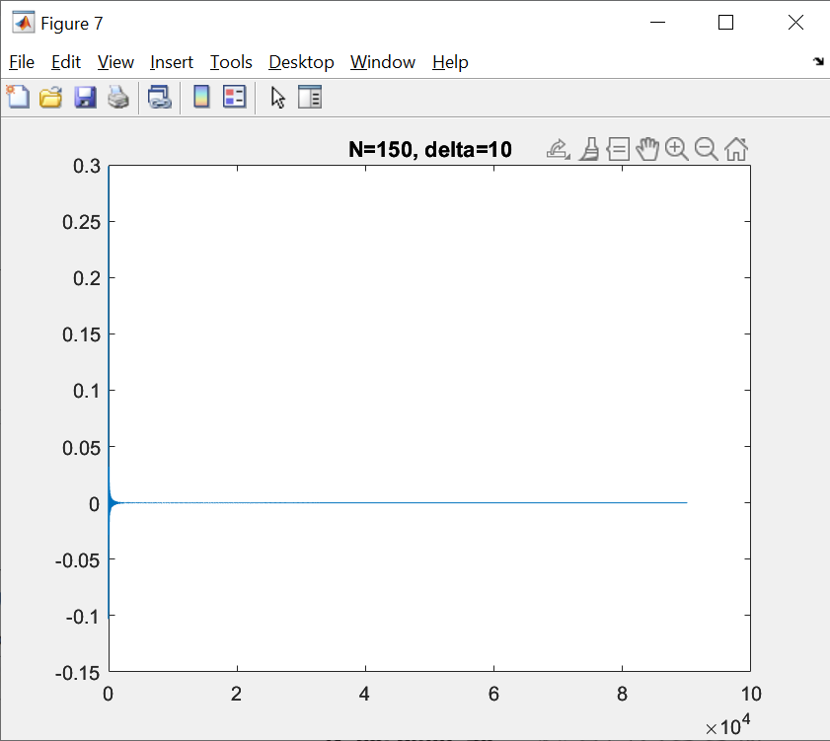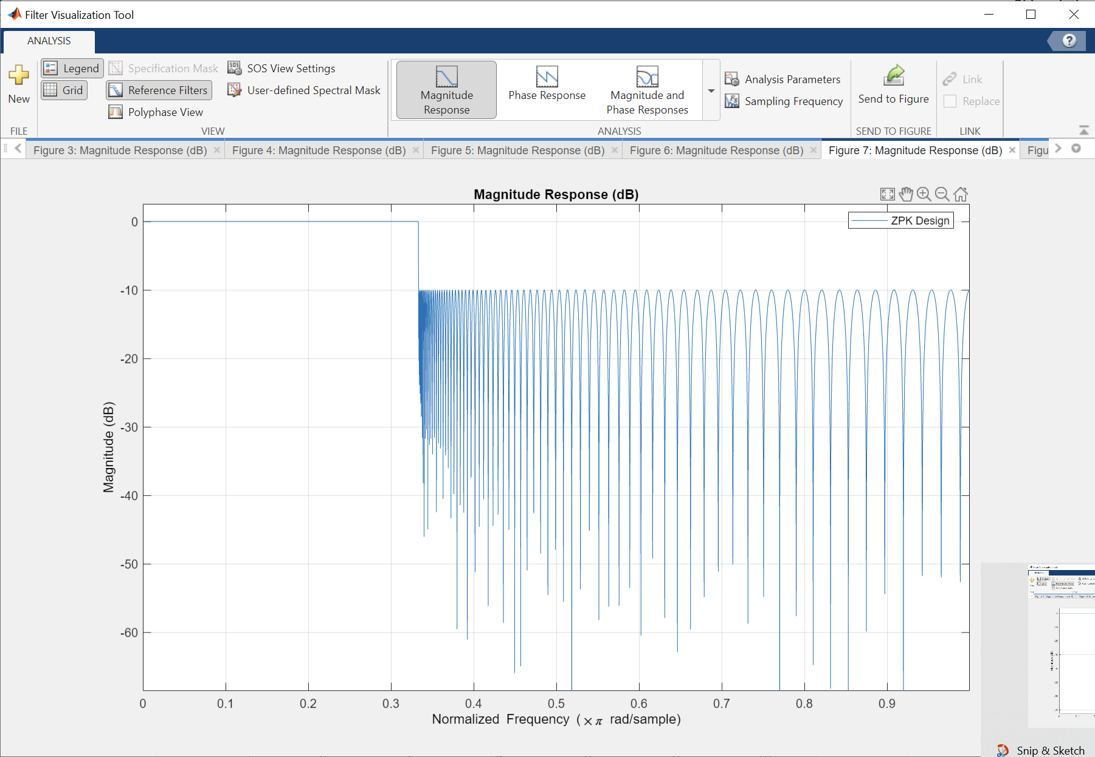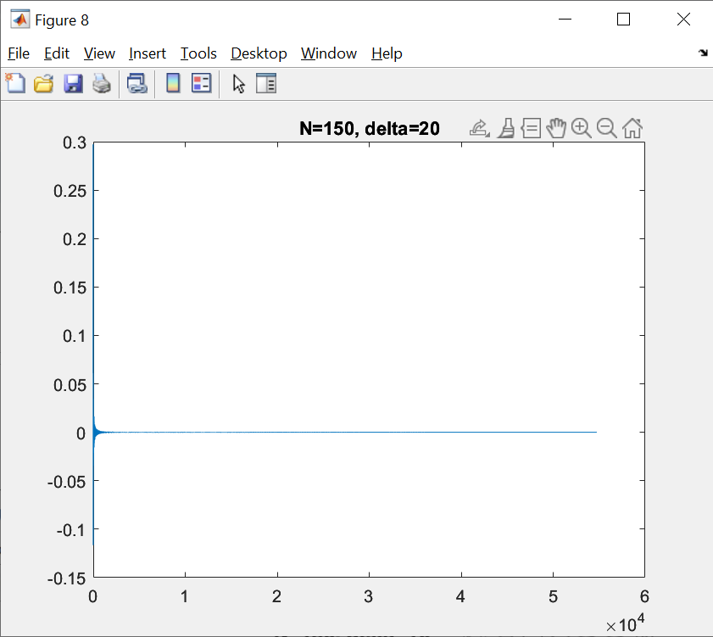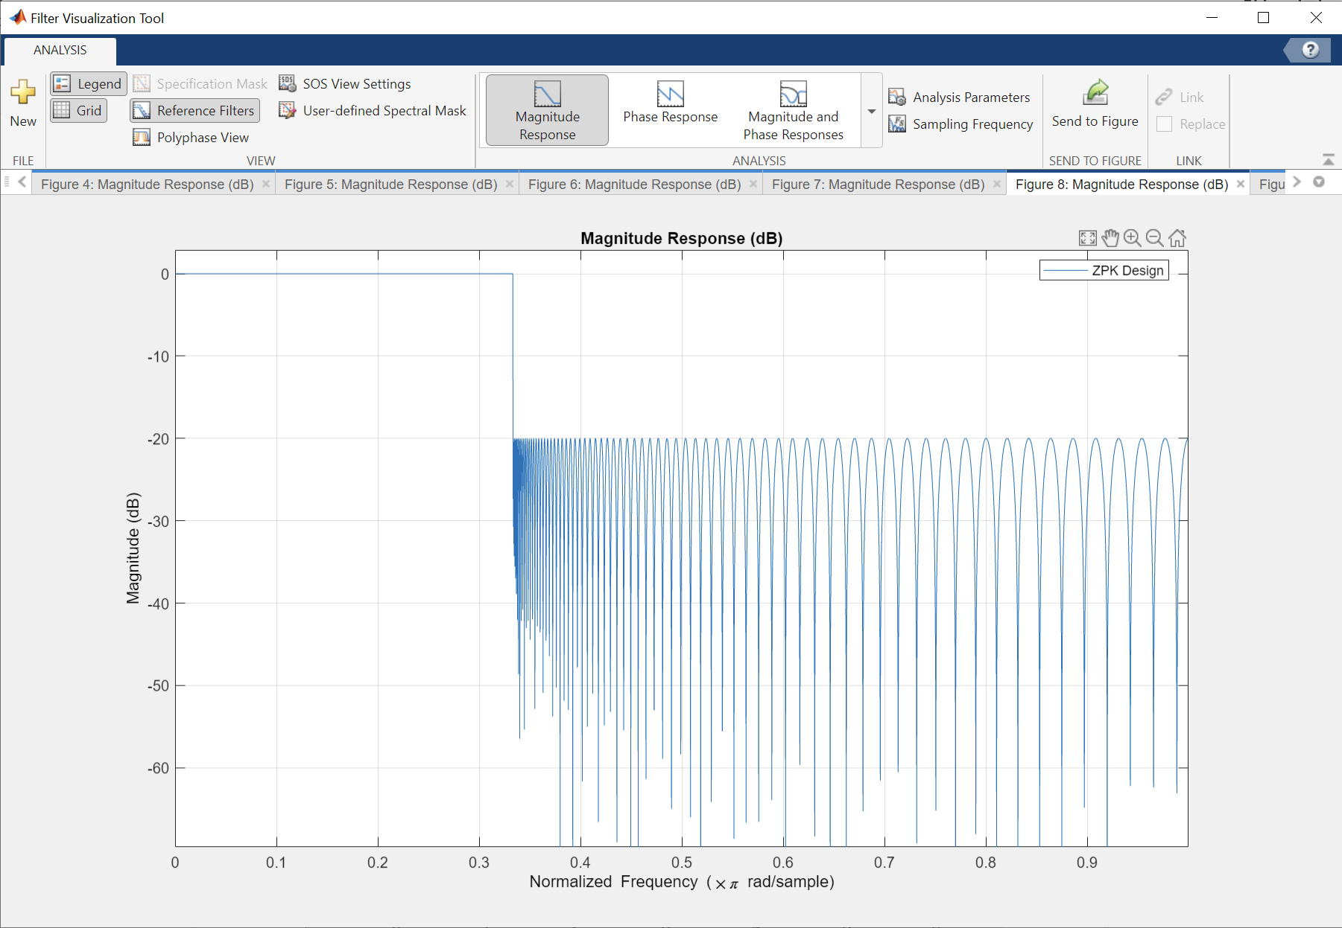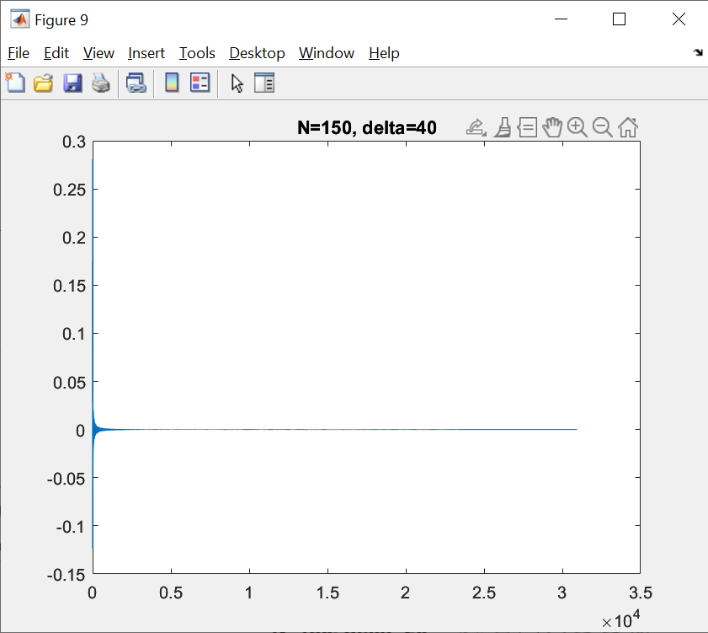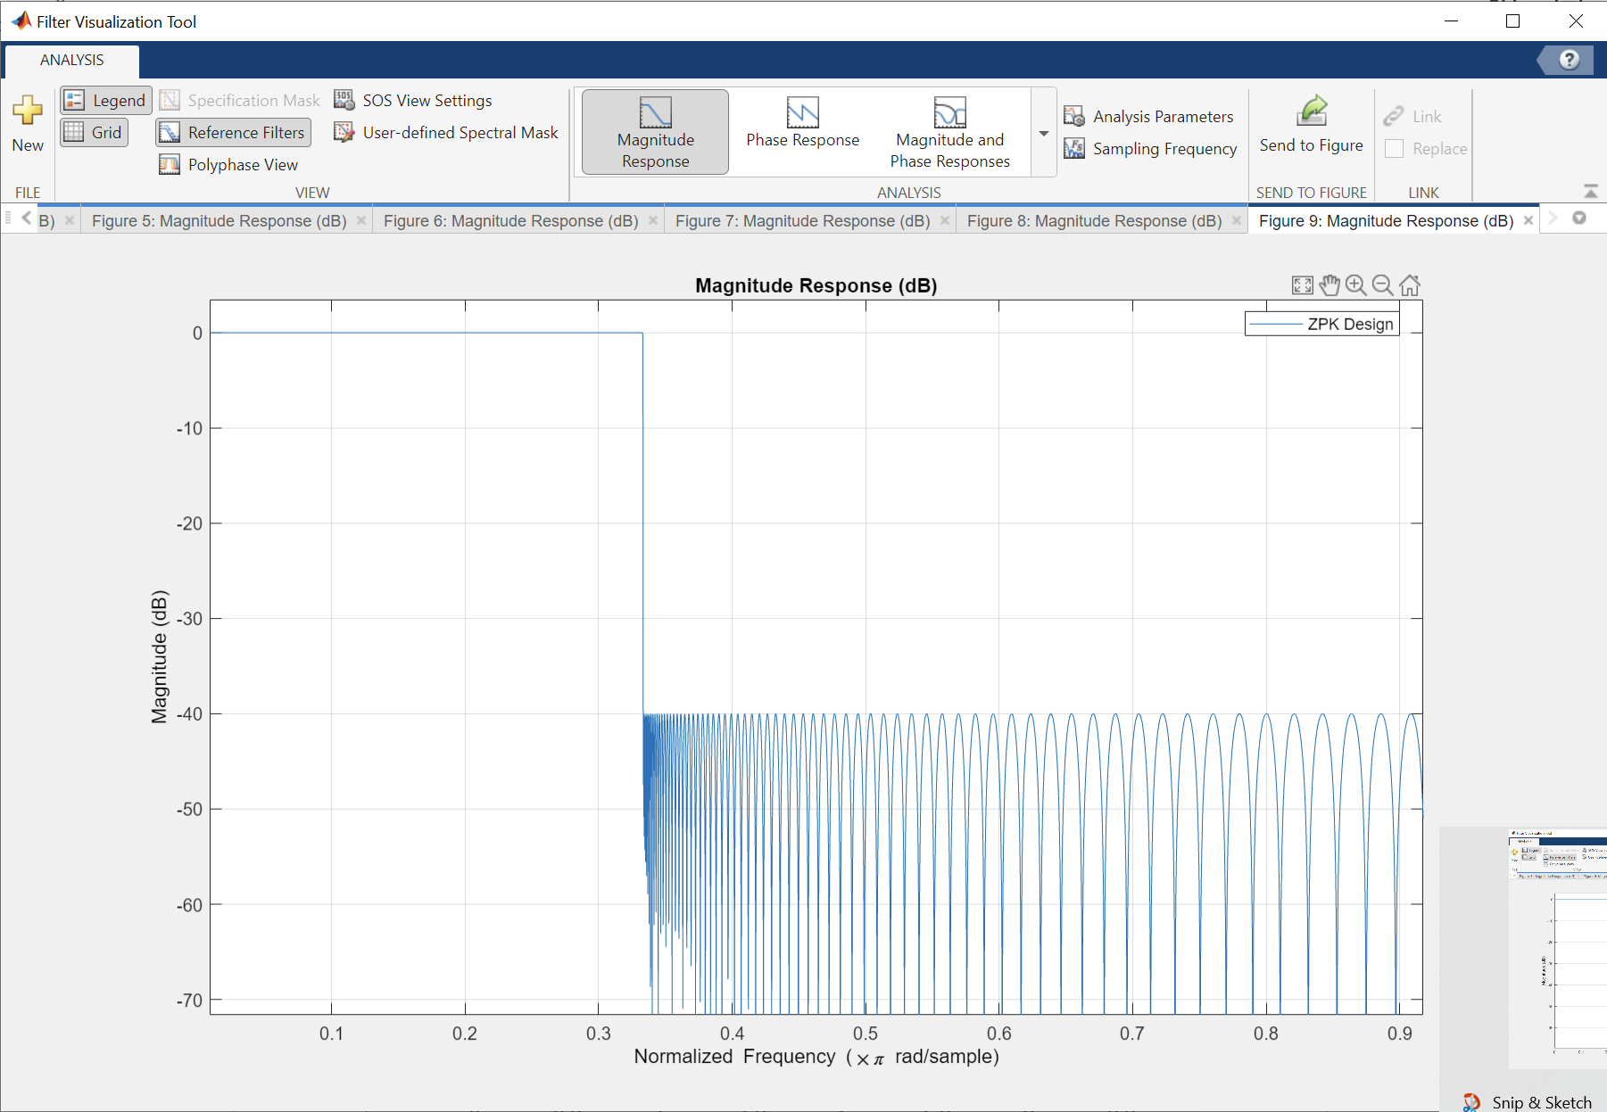

(3)

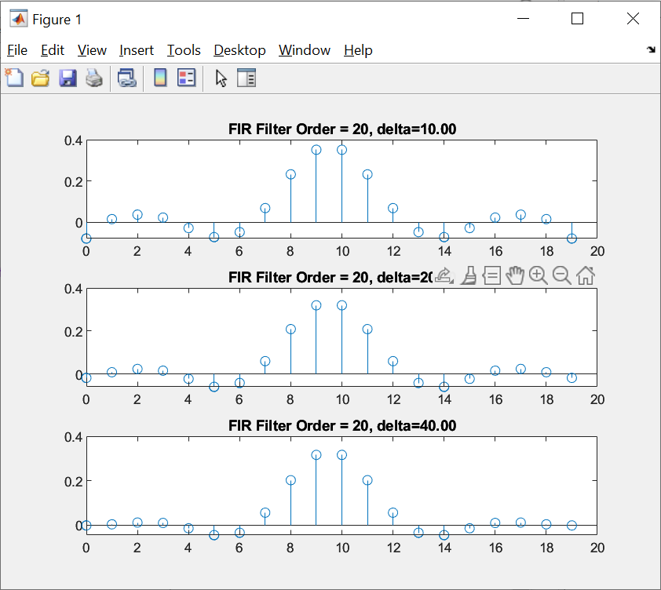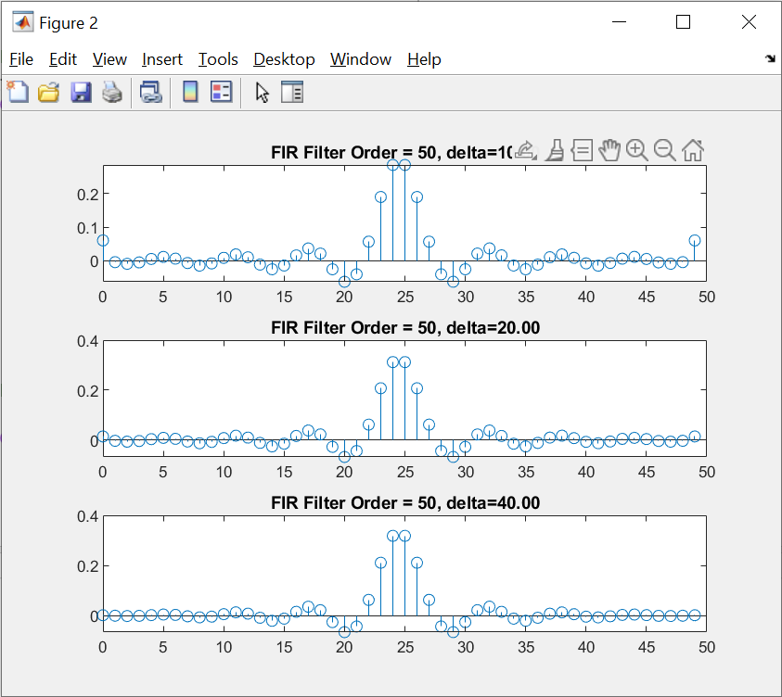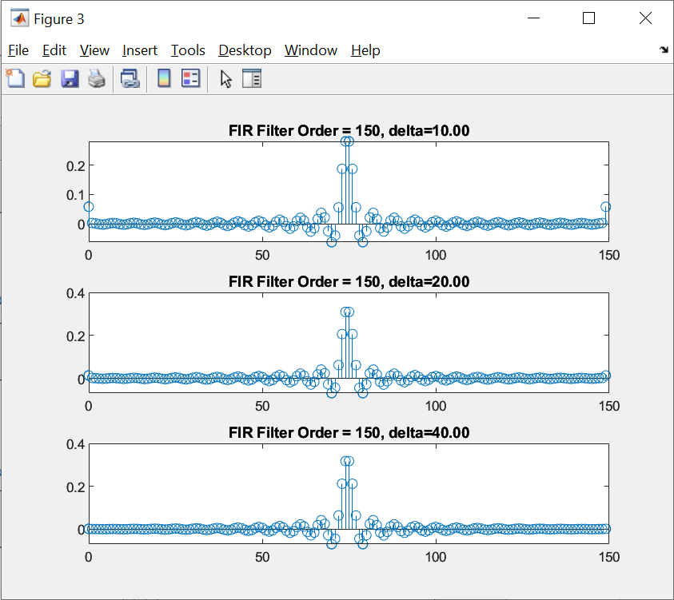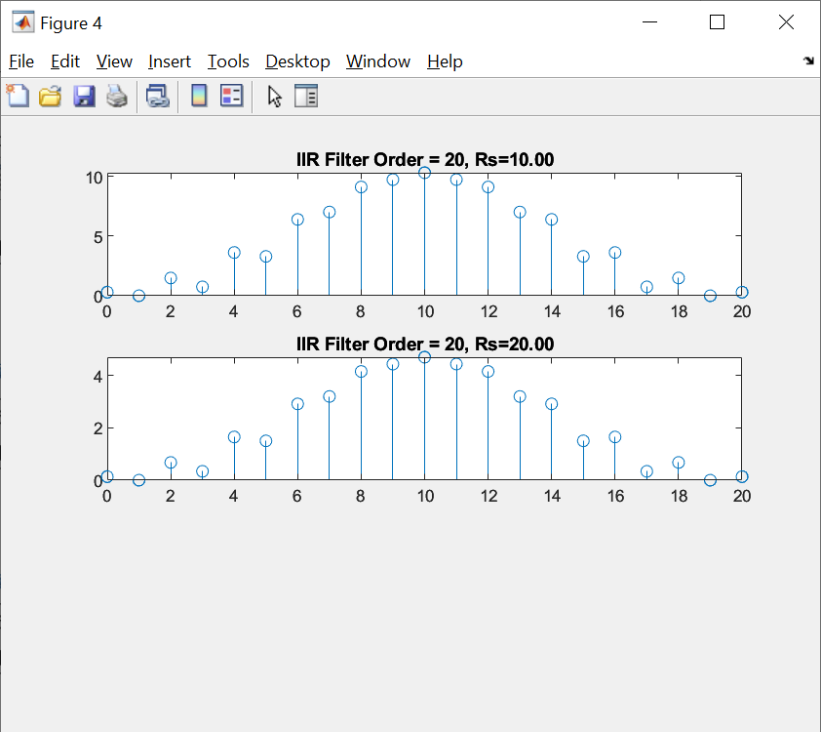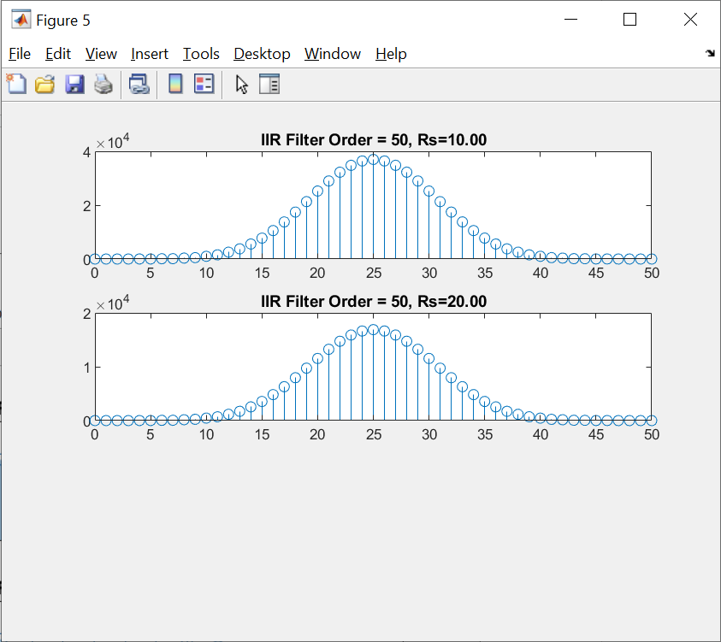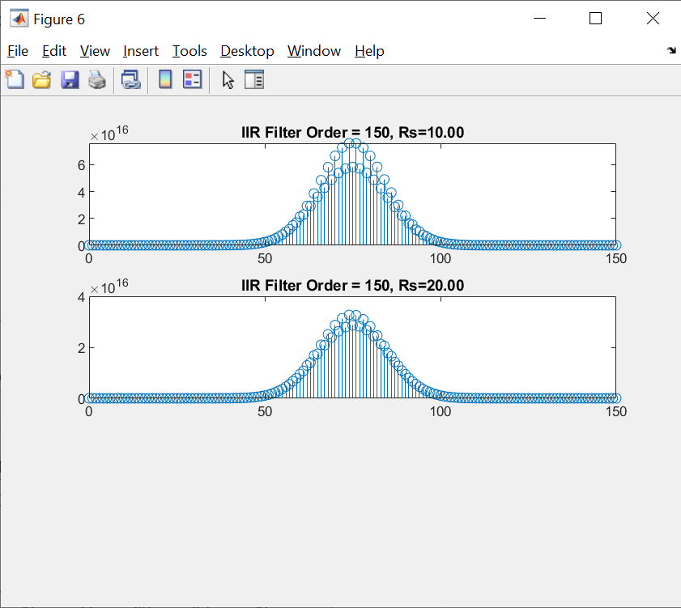

They don’t appear to be infinite.

(d)

FIR:

FIR filter has a flatter magnitude response with minimal ripples in the passband.

FIR filter exhibits a linear phase response across the entire frequency spectrum.

IIR:

Chebyshev Type II IIR filters show ripples in the passband.

IIR filters introduce non-linear phase characteristics, particularly in the transition region.

(e)

Gaussian noise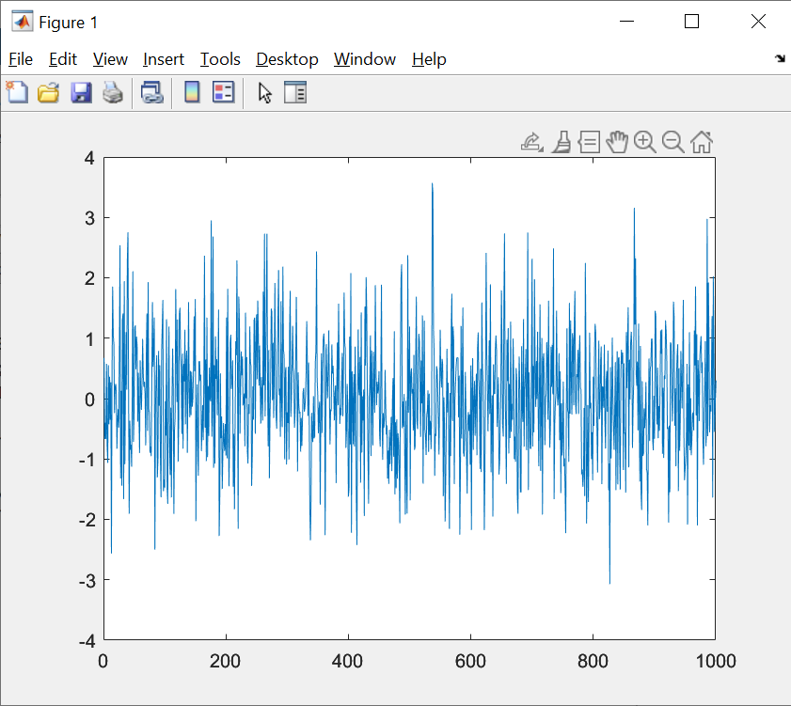

the output

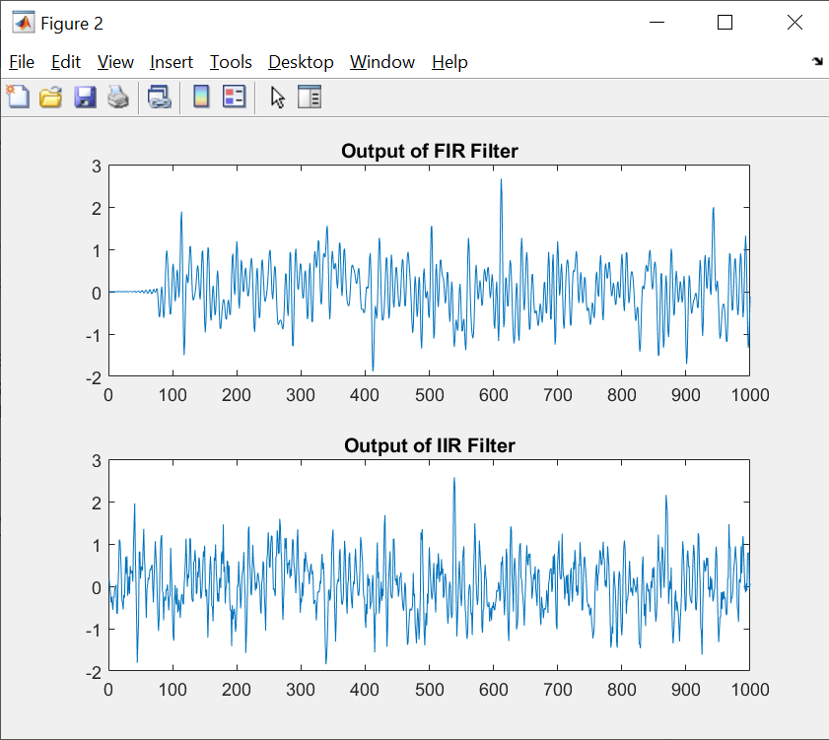

The maximum differences and variances of the two filters are approximately similar. In this case, the errors obtained are not substantial, and both filters perform well.

**2. Experiment on the TMS 320 DSP processor: IIR filter design and group delay**

**equalization**

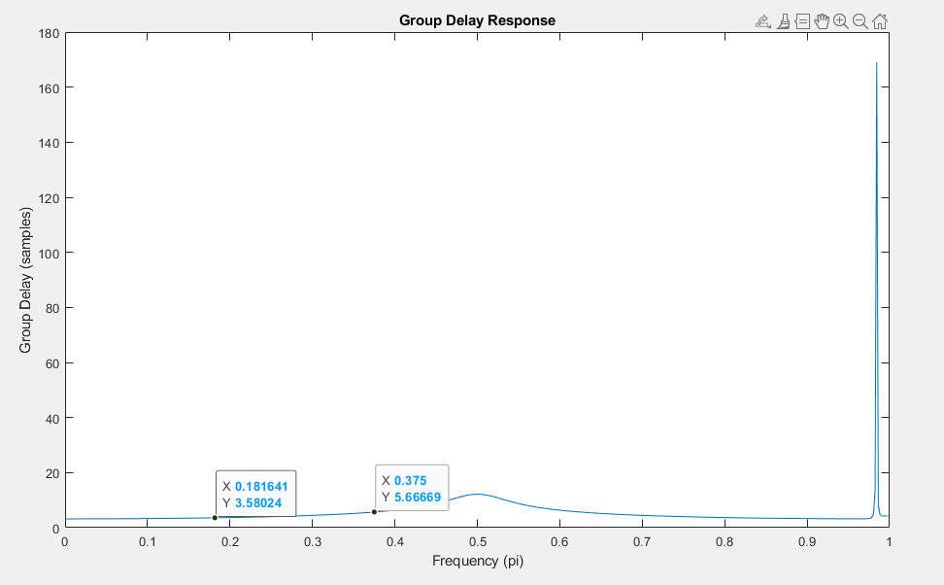

As we can see:

Group delay for f1: 4

Group delay for f2: 6

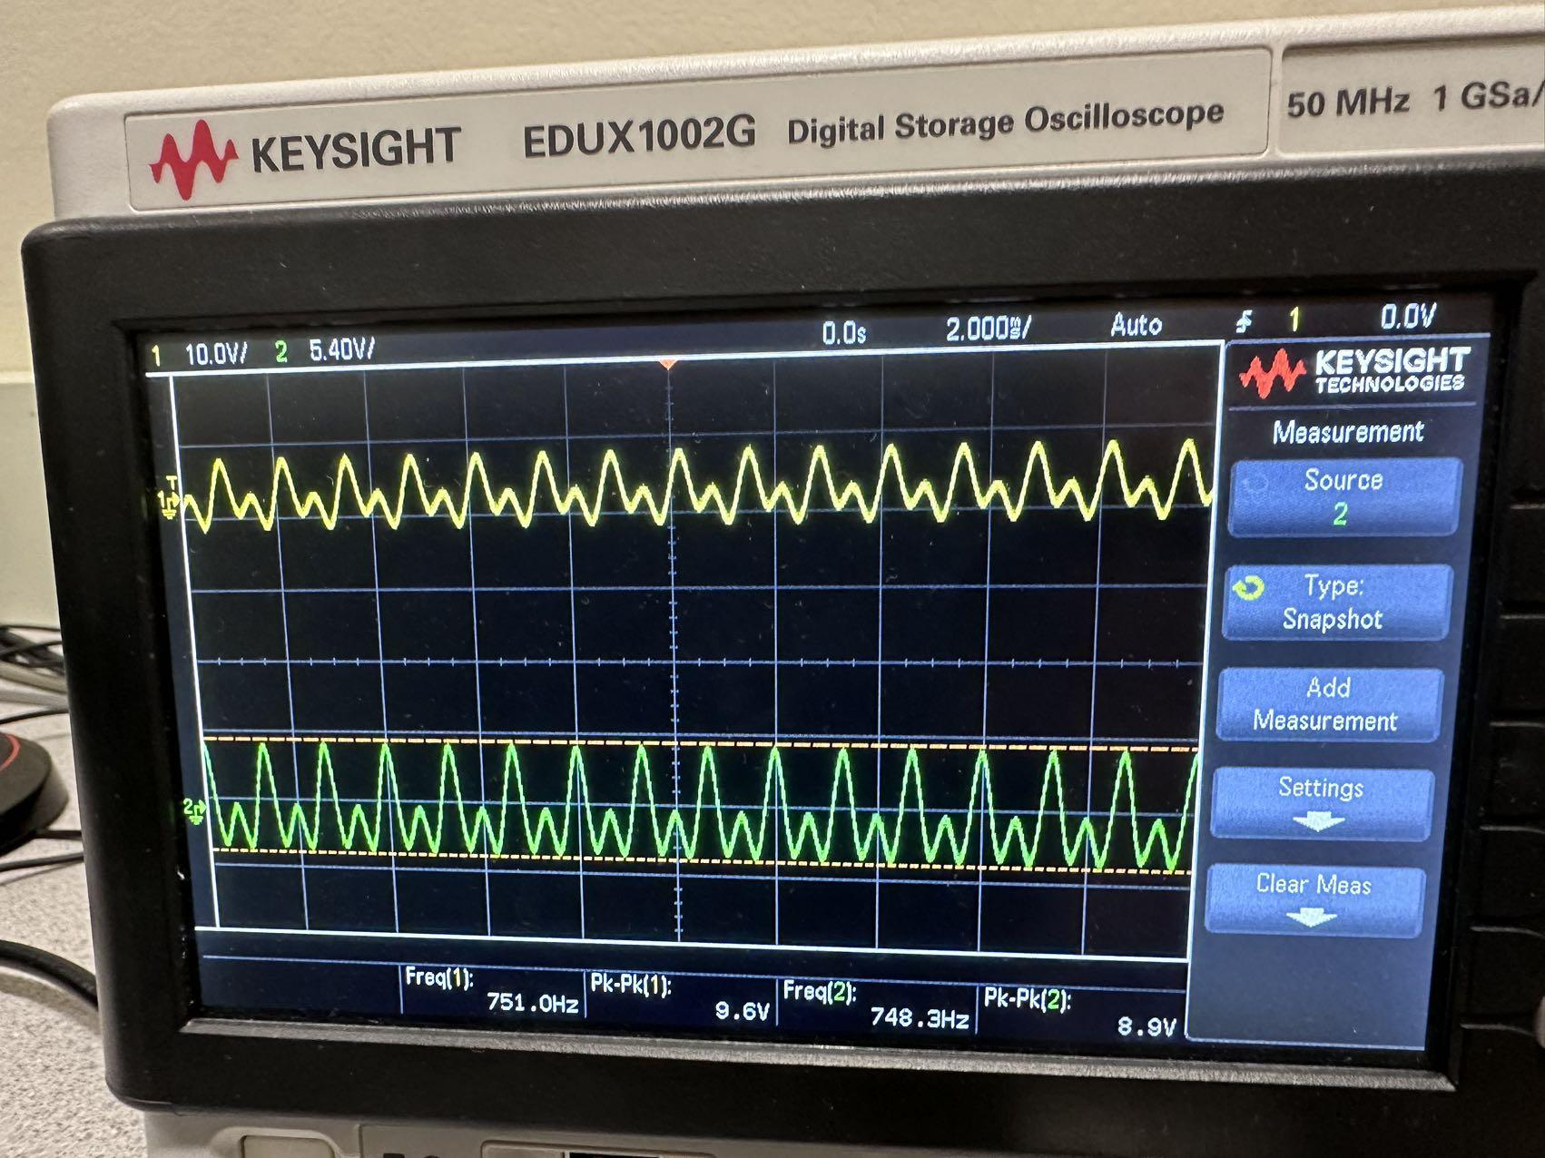

As we can see, with group delay from f1 and f2, there is a phase shift between the input and output, and due to filter, the shape of the input and output is different as well.

B:

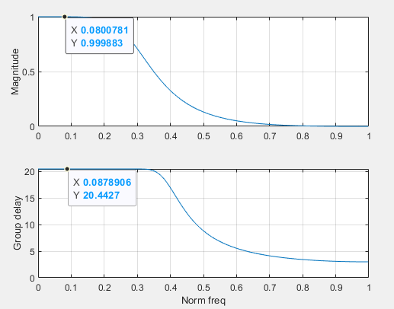

We set M2 to 10, which will generate a really flat group delay.

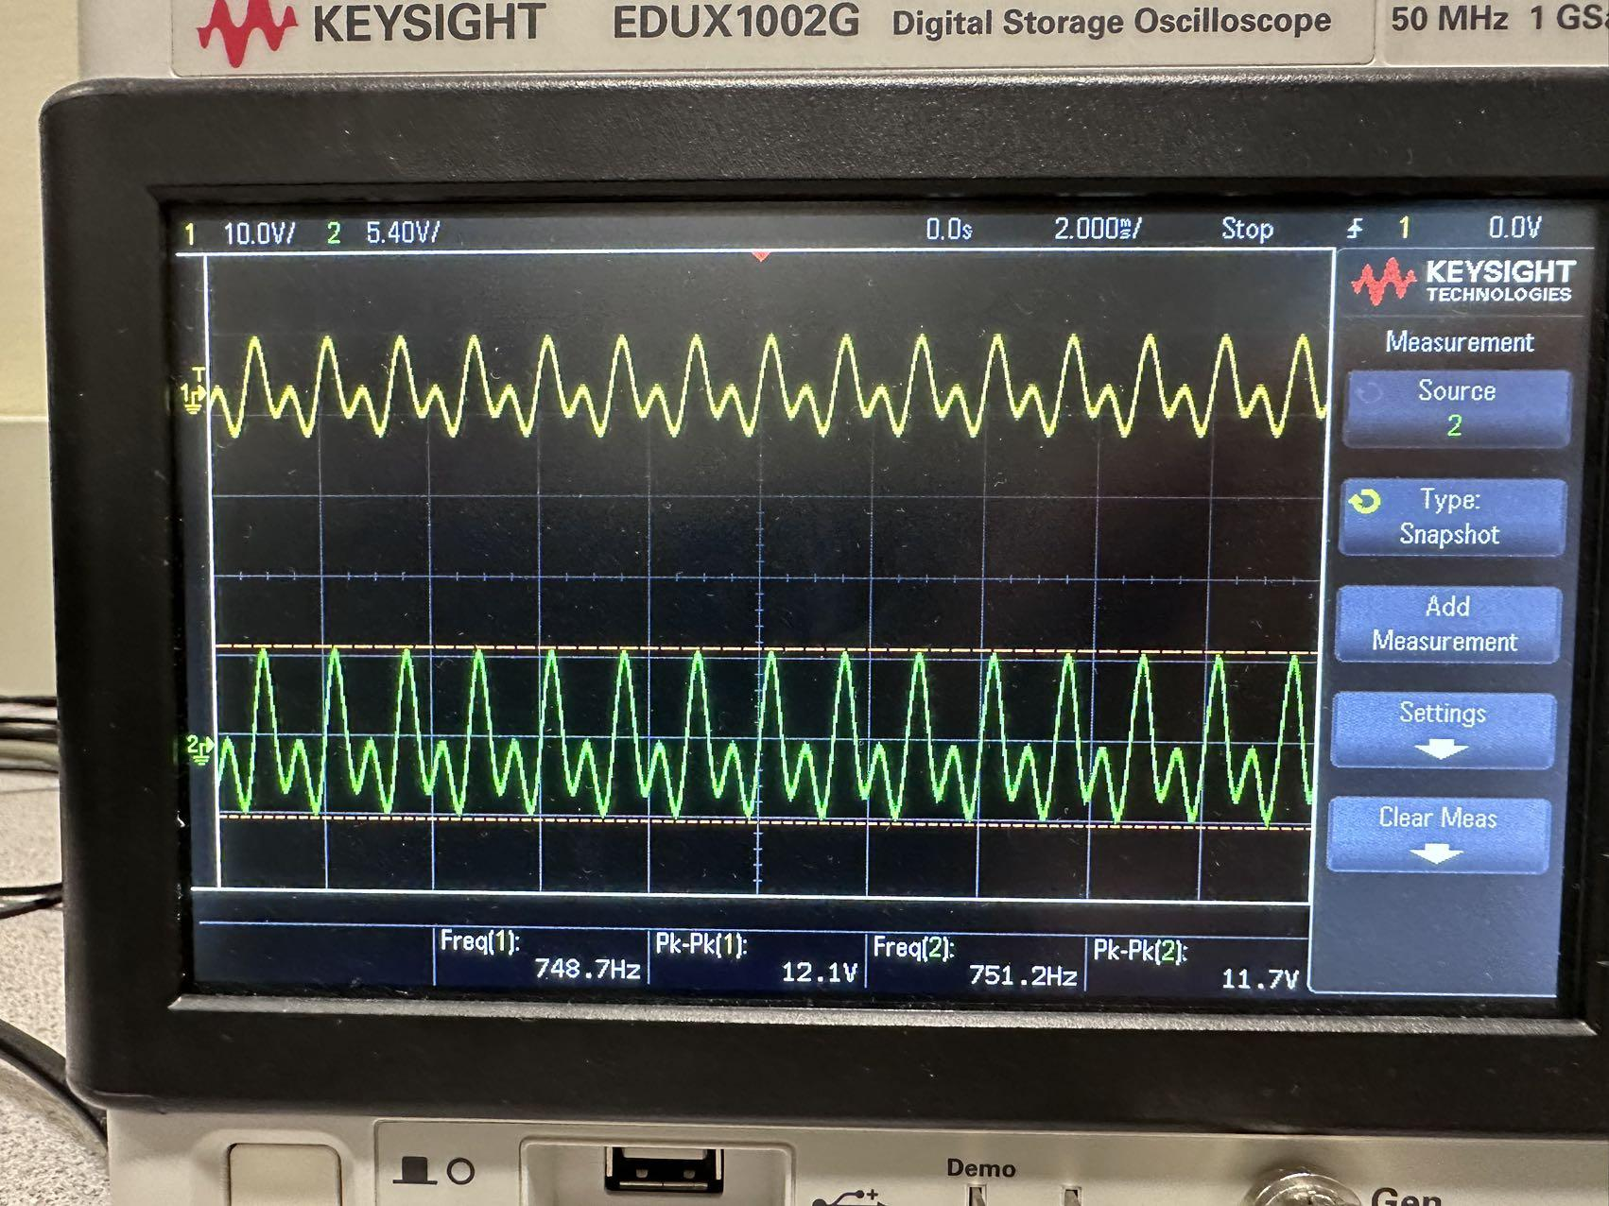

As we can see, we set the group delay as flat and as small as possible, so there is no phrase difference. And we conv the all pass filter with the original filter, so that the shape of the input and output is identical.